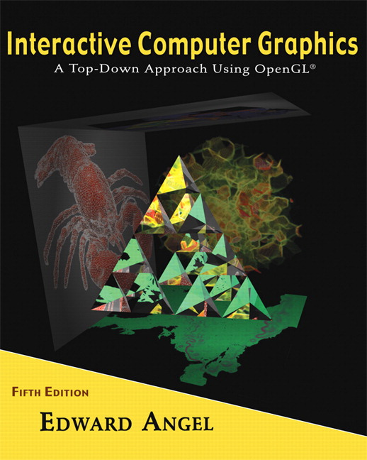 COSC 4370

Name: Terminal #

Programming Assignment 4 Hours:
Acceptance Testing Check Sheet:
V
X
?

CHECKLIST (YOU MUST CHECK BOXES YOURSELF!):

- SUBMITTED .zip PROJECT to BB?________________

- SUBMITTED PROJECT HARDCOPIES?(Screenshots + Source)___

Particle Systems:

- ACCEPTANCE TESTING Step 1?________ _______________

- ACCEPTANCE TESTING Step 2?__________________________

Navigation:

- ACCEPTANCE TESTING Step 1?__________________________

- ACCEPTANCE TESTING Step 2?__________________________

- ACCEPTANCE TESTING Step 3?__________________________

Source Code:

- ACCEPTANCE TESTING Step 1?__________________________

SUBMITTED Acceptance Testing .doc to BB___ __ ___

I CERTIFY THAT THIS IS MY OWN WORK and THE CHECKBOXES reflect the completion of these DELIVERABLES.

SIGNATURE:

